Phase02 – Week01 – Day01:
Class Assignments:
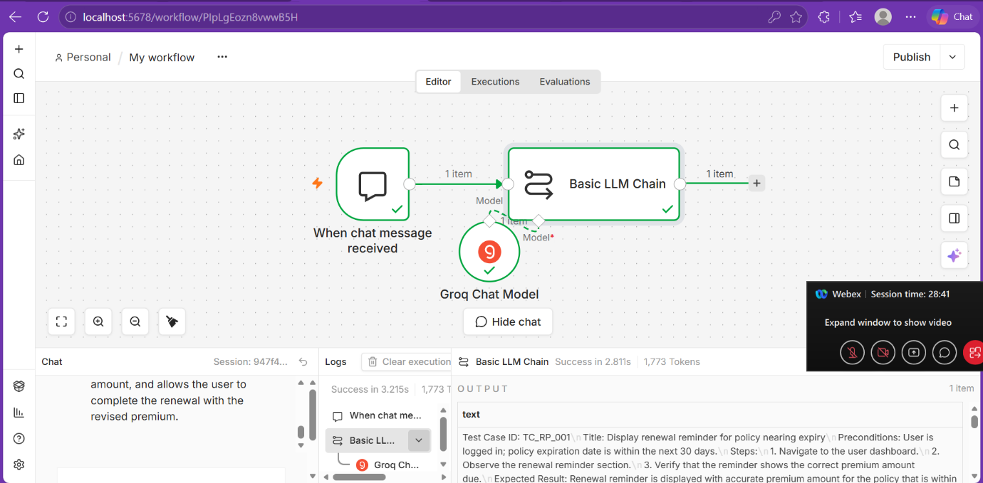
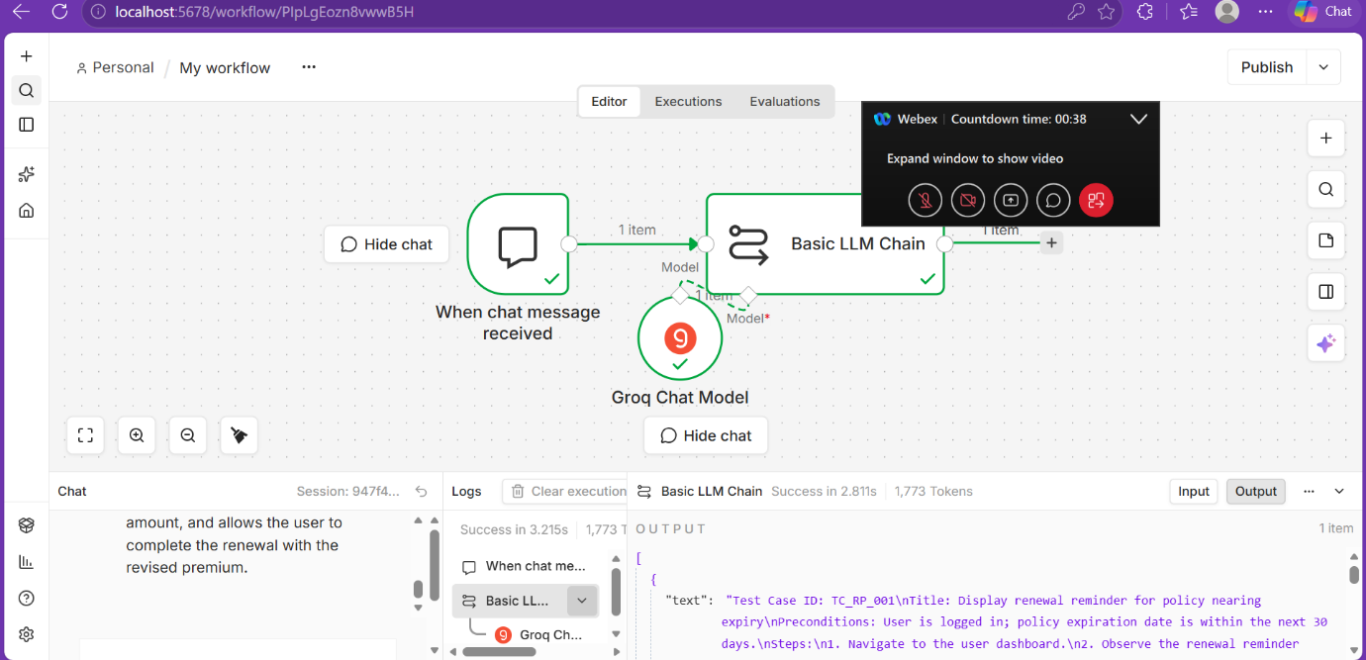
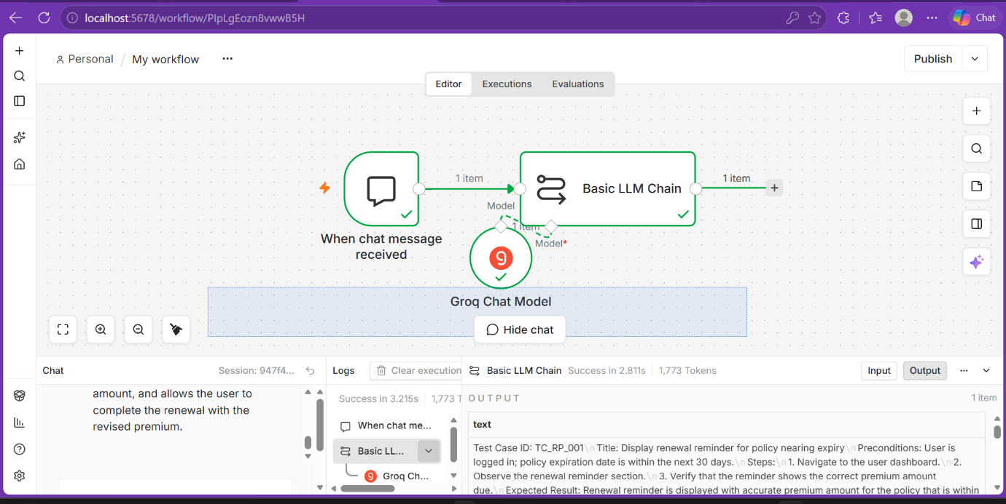
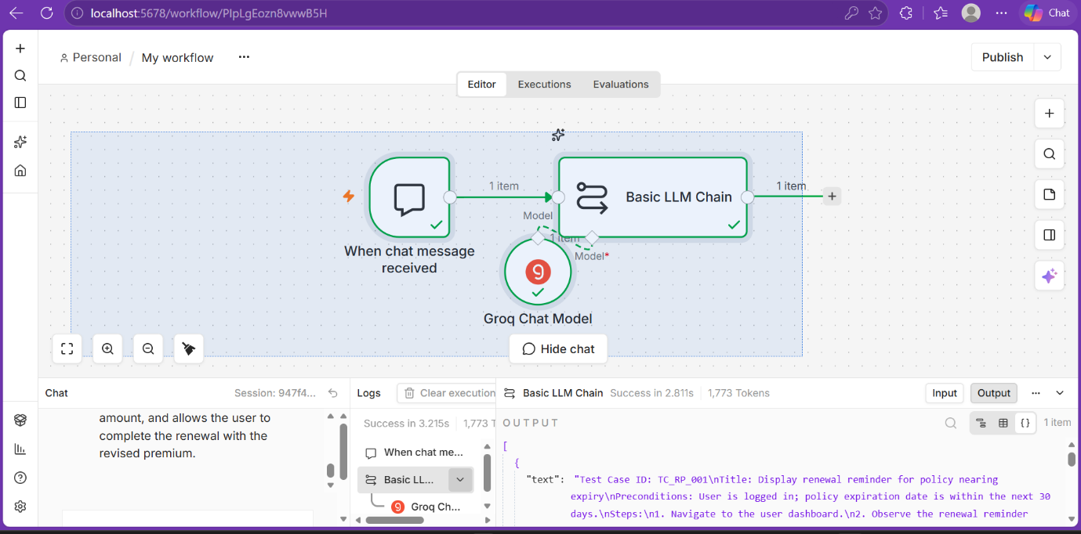
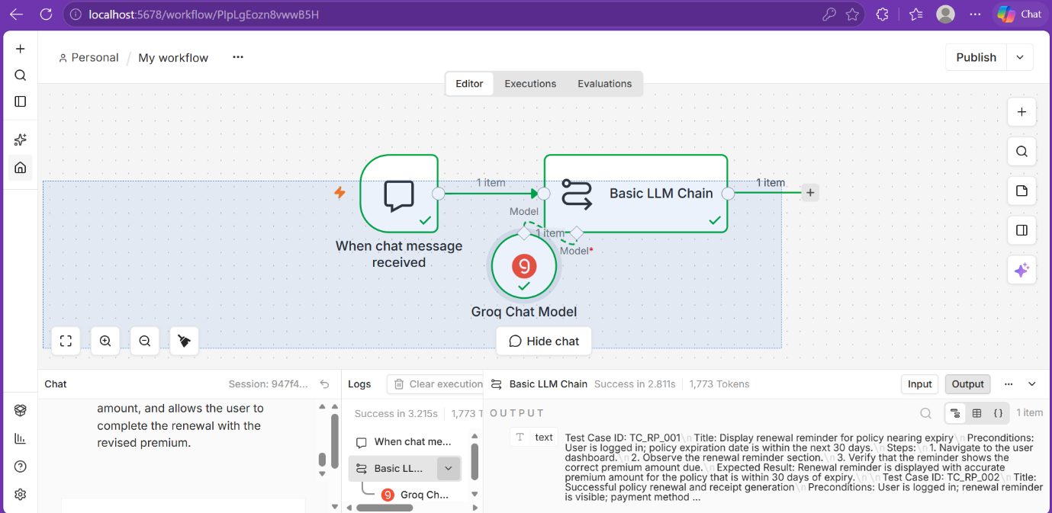
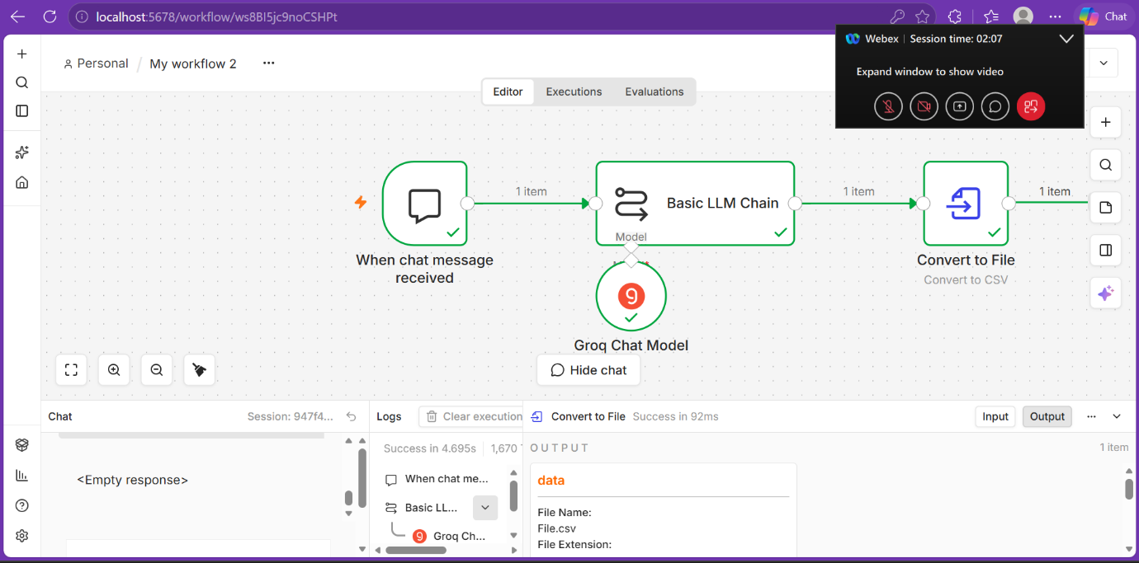
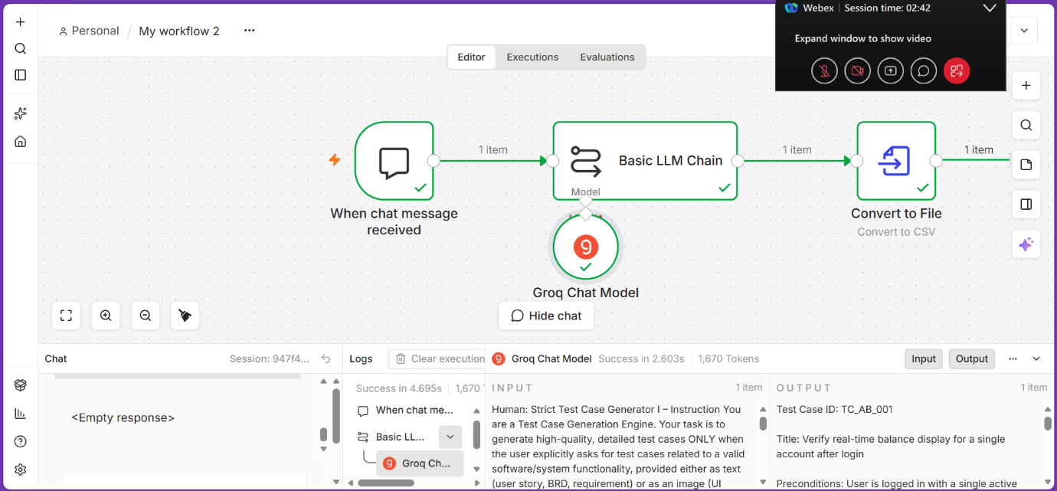
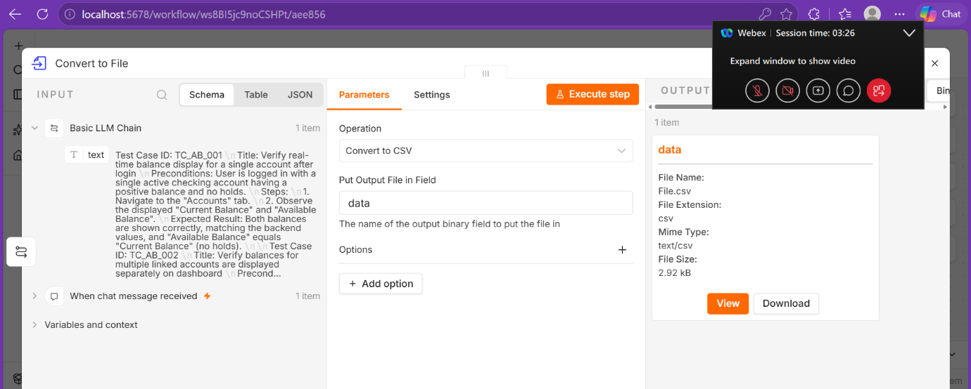
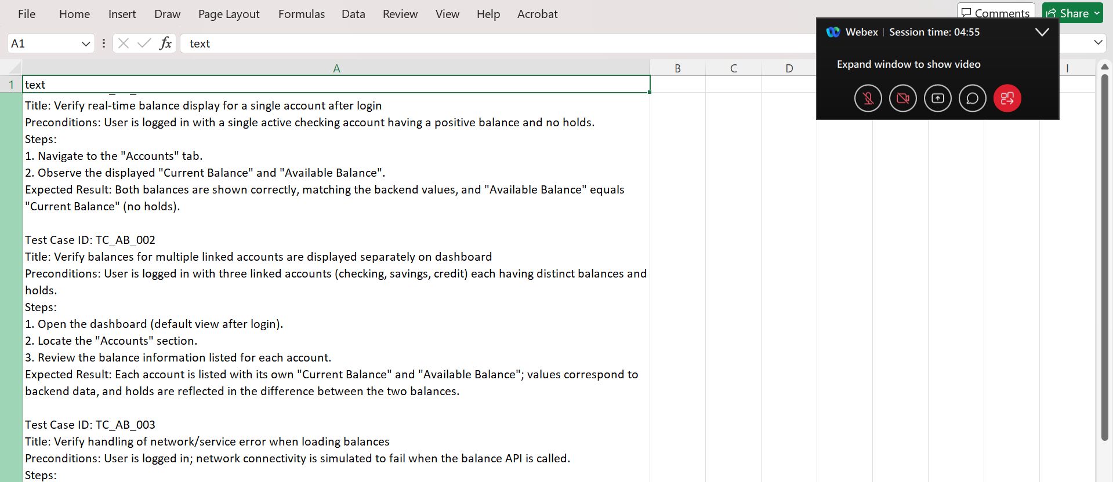
Home Assignments:
- Case Study – Flow AI:
Flow AI works in real estate where agents need to continuously follow up with hundreds of leads.
- What problem/use case they had:
The major problem was manual customer outreach:
- Cold calling
- Sending emails
- Sending SMS/text messages
- Following up with old leads
- Inviting contacts to open houses
- Maintaining compliance with US messaging regulations
An agent could spend 3–5 hours every day doing follow-up activities.

- Where and why they implemented n8n:
Initially, Flow AI used: Zapier + Twilio + Mailchimp. But this became difficult to manage because the systems were disconnected.
They had problems such as:
- Customer data spread across different systems
- Difficult opt-in/opt-out enforcement
- Lack of centralized logging
- Compliance concerns
- Difficult customer isolation
- Difficult scaling
So they chose n8n Enterprise, self-hosted as the automation backbone.
Why n8n?
The important reasons were: Flexibility + integrations + scalability + control + customization
Instead of developing every integration themselves, Flow AI could connect databases, AI models, messaging systems and email services through n8n workflows.
- How was the workflow implemented?
The architecture is built around a simple principle. Each customer runs in their own dedicated n8n project. This guarantees strict data isolation, prevents accidental cross sends, and allows custom workflows per customer without affecting others.
The user interaction starts with voice. Flow AI uses ElevenLabs to convert the voice instruction into structured information, which is then sent into n8n through a webhook.
Once n8n receives the request, the workflow performs multiple tasks.
Step 1 – Receive request
The voice assistant sends structured information to an n8n webhook.
Step 2 – Retrieve contacts
n8n communicates with their PostgreSQL database and retrieves the relevant contacts.
Step 3 – Check permission
Before sending anything, the workflow verifies whether the contact has opted in.
This is critical because Flow AI operates under US communication regulations such as 10DLC and CAN-SPAM.
Step 4 – AI generates personalized content
AI generates the appropriate outreach message.
Instead of sending exactly the same message to everybody, the system can personalize the communication.
Step 5 – Compliance safeguards
The workflow applies safeguards before the message is sent.
Step 6 – Send messages
The workflow routes the messages through:
- SMS providers
- Mailgun/email
Step 7 – Audit logging
Every step is logged, creating a complete audit trail.
- How n8n helped them in real-world scenarios:
Before n8n: An agent might need 3–5 hours to perform follow-up. For a large campaign, Several days could be required.
After n8n: The same campaign can typically execute in < 60 seconds.
Flow AI says campaigns that previously took days can now run in under a minute, and agents can initiate them through a single voice command.
- Template:
